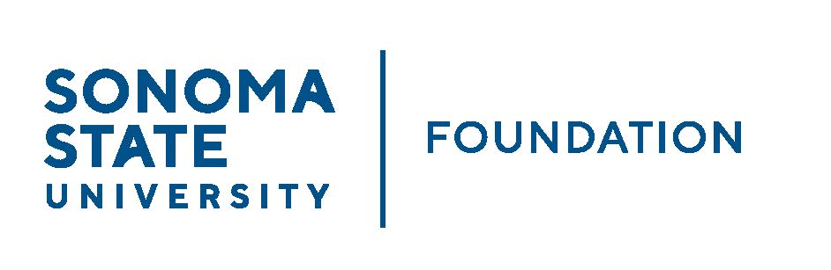

INVESTMENT COMMITTEE AGENDA

SSU Foundation Investment Committee Agenda
Wednesday February 9, 2022
2:30 - 4:30 p.m.
Video/Teleconference Meeting

Members: Brent Thomas (Chair), Ian Hannah, Mario A. Perez, Amanda Visser, Monir Ahmed, Tom Gillespie, Terry Atkinson, Doug Jordan

Committee Staff: Kyle Bishop-Gabriel, Christina Shoptaugh

Guests: Todd Au, Tony Parmisano, Drew Aviles – Graystone Consulting

OPENING COMMENTS

APPROVAL OF THE MINUTES
  - 10.20.21 Meeting Minutes

NACUBO-TIAA STUDY OF ENDOWMENTS 20/21 COMPARATIVE DATA

GRAYSTONE – POOLED ENDOWMENT INVESTMENTS
  - Quarterly Update

GALBREATH ENDOWMENT INVESTMENTS QUARTERLY REPORT

REVISED RESPONSIBLE INVESTING POSITION STATEMENT

REVISED STUDENT MANAGED INVESTMENT FUND (SMIF) SRUCTURE

QUASI ENDOWMENT PROPOSAL ON ESTATE GIFT

OPEN ITEMS

