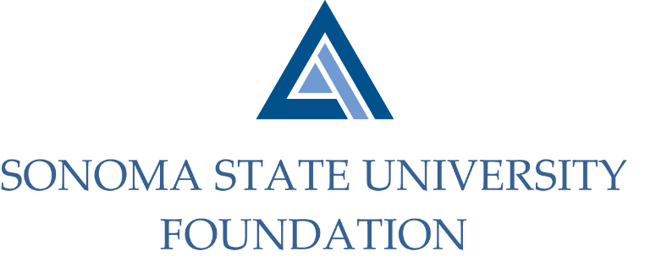

PHILANTHROPY COMMITTEE AGENDA

SSU Foundation Philanthropy Committee
Thursday February 18, 2021
Zoom/Teleconference
(for dial-in instructions please email kyle.bishop-gabriel@sonoma.edu)
2:00 – 3:30 p.m.

Members: Terry Atkinson (Chair), Tom Isaak, Robert U’Ren, Ian Hannah,
Mario Perez

Committee Staff: Kyle Bishop-Gabriel

Opening Comments

Approve 11.5.20 Meeting Minutes

University Advancement Philathropic Update & Planning

Giving Day

SSUF Board Member Giving Minimums

Open Items

