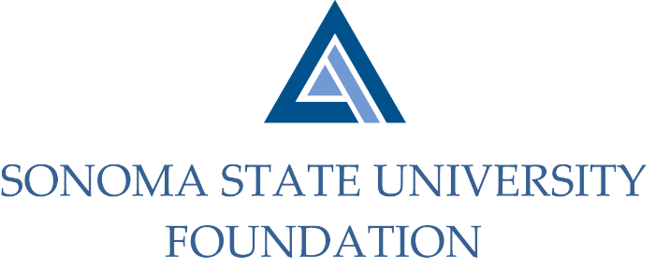

INVESTMENT COMMITTEE AGENDA

SSU Foundation Investment Committee Agenda
Thursday November 7, 2019
Stevenson Hall Academic Affairs Conference Room #1040
2:30 - 4:30 p.m.

Members: Ian Hannah (Co-Chair), Michael Sullivan (Co-Chair),
Gordon McDougall, Amanda Visser, Joyce Lopes, Tom Gillespie, Michael Troy, Brent Thomas, Terry Atkinson

Committee Staff: Kyle Bishop-Gabriel, Christina Shoptaugh

Guests: Todd Au, Tony Parmisano, Drew Aviles – Graystone Consulting

- OPENING COMMENTS

- APPROVAL OF THE MINUTES
  - 8.21.19 Meeting Minutes

- NACUBO-TIAA STUDY OF ENDOWMENTS 18/19 TALKING POINTS

- GRAYSTONE – POOLED ENDOWMENT INVESTMENTS
  - Quarterly Update

- GALBREATH ENDOWMENT INVESTMENTS QUARTERLY REPORT

- QUASI ENDOWMENT FUND POLICY DISCUSSION

- OPEN ITEMS

