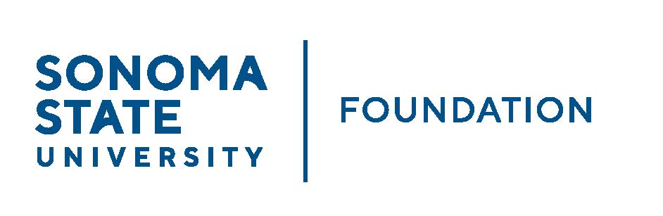

INVESTMENT COMMITTEE MINUTES

SSU Foundation Investment Committee
Wednesday November 2, 2022
2:30-4:30p.m.
Hybrid Meeting (in-person/video)

Members Present: Brent Thomas (Chair), Ian Hannah, Mario A. Perez,
Amanda Visser, Monir Ahmed, Tom Gillespie,
Mike Sullivan, Doug Jordan

Committee Staff Present: Kyle Bishop-Gabriel, River Christina Cullen

Guests Present: Todd Au, Tony Parmisano, Drew Aviles, Kyle O’Keefe – Graystone Consulting

Members Absent: Terry Atkinson

OPENING COMMENTS
Brent Thomas opened meeting opened at 2:34pm.

Perez provided the following campus updates to Committee.

- Started semester off very busy. Advancement put on a couple of events; Sip & Chat to connect donors and student scholarship recipients and Seawolves Say Thank You that invited campus participation and notes of “thankfulness” from students, staff and faculty.

- Parent and Family weekend combined with preview weekend for new families. Wine reception for parents. President Lee attended and took time to speak to each family. Was a great weekend for an introduction to all the different programs and what SSU has to offer them as well as for families to enjoy time with current students.

Perez shared that there is great momentum happening on campus to
move SSU forward.

Lastly, Perez reminded Committee members of the upcoming Ribbon
Cutting Event for Stevenson Hall on Dec. 2nd. It will be campus an
outside community gathering to celebrate the opening of the new building.

APPROVAL OF THE MINUTES
(see 11.2.22 meeting packet)

Action: Committee unanimously approved meeting minutes from 8.17.22.

21/22 ENDOWMENT TALKING POINTS
(see 11.2.22 meeting packet)

Ian Hannah reviewed 21/22 Endowment Talking Points with Committee.
He noted that the information provided is based primarily on data
submitted via the NACUBO-TIAA Study of Endowments (NTSE) 21/22.

Hannah reviewed the following of preliminary information:

  - Survey questions main focuses were on Endow Market Value, Asset allocation, returns, spending, with continued focus on responsible investing – including diversity, equity and inclusion considerations (DEI)
  - Reviewed additional talking points on the summary sheet
  - Will compile and share comparative data once study is finalized and released

Hannah noted that the survey has been submitted and comparative
results will be available in the coming months.

Committee members had suggested edits to show 5-year, 10-year and
cumulative distributions on the sheet to show longer term impact of
endowment distributions to the campus.

GRAYSTONE – POOLED ENDOWMENT INVESTMENTS
(see 11.2.22 meeting packet)
Tony Parmisano provided Capital Market updates with Committee. He
Noted that it had been a very challenging environment with stocks and
bonds in the past quarter. Everything outside of energy has been down
with lots of volatility. Mostly all areas have been suffering together. Report
shows a down market for end of quarter 9.30.22 but has since recovered a
majority of the loss in the past month.

Todd Au provided SSUF endowment portfolio review to Committee.
Performance for Q3 as of 9.30.22 ended at -4.1%. Au noted that one area
Of the portfolio that has produced positive results is in the hedge funds
composite. Private Real Estate has been another area of great
performance.

Generally speaking, although pessimistic in the short term, from a long
Term policy perspective, Graystone noted there is strong likelihood we
can meet our goals and objectives.

Au continued to review the current asset allocation and noted underweight
In equities and fixed income (due to current market conditions) and
overweight in private investments and hedge funds.

Au gave heads up on a new fund opportunity that will be coming onto the
market. Once additional information is available after their review they will
be reaching out to add fund into private equity allocation. After discussion,
Zoom meeting will be scheduled with Committee to provide needed
Additional information before investing in fund.

Lastly, Au noted that Graystone suggests making an edit to current IPS to
increase max % of portfolio illiquidity to allow additional flexibility in adding
private investments to portfolio. Suggested changes will be reviewed at
next scheduled meeting. Current illiquidity (less than one-year liquidity) is
roughly 15% of the portfolio compared to a policy maximum of 20%. A
revised maximum of 30% is being recommended.

GALBREATH ENDOWMENT INVESTMENTS QUARTERLY REPORT
(see 11.2.22 meeting packet)

Hannah provided high level review for the recent quarterly report. He
noted the following:
- Performance down 5% for last quarter; up 1% annualized over last 5 years.
- 9/30/22 market value $1.1M vs. corpus of $1M.
- Annual distribution made in October to Galbreath Preserves program totaling close to $40,000 based on 3% of three-year rolling average of endowment market value.

Hannah also noted Investment Manager’s message on the ESG
evaluation tool report. Manager shared that despite the portfolio only
having one official “ESG” fund, the underlying holdings in the portfolio
screen well.

OPEN ITEMS
Before conclusion of meeting, Hannah shared information with Committee from recent CSU AOA Philanthropy Committee meeting topics. He noted a couple of topics:

  - San Francisco State University IPS revisions to be values based (social equity and environmental sustainability utilizing ESG investing)
  - Best practices on periodic Investment Advisor evaluation and/or RFP

Meeting adjourned at 4:18pm.

Ian Hannah Kyle Bishop-Gabriel – Redacted Signature
Ian Hannah Ian Hannah – Redacted Signature
__________________________ __________________________
Minutes Approved by: Minutes Prepared by:
Ian Hannah Kyle Bishop-Gabriel
Chief Operating Officer & Sr. Advancement/Foundation
Secretary, SSUF Analyst & Asst. to the VP, SSU

