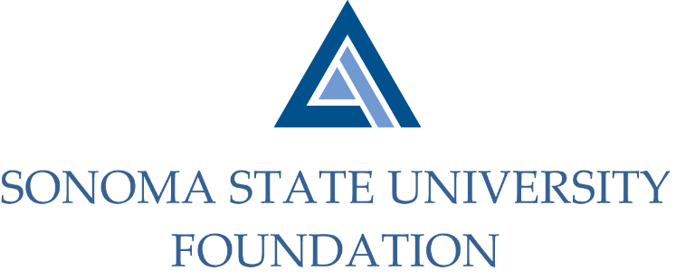

Executive Committee Session of the Board of Directors
Thursday November 19, 2020
2:00-3:30pm
Video/Teleconference

CLOSED SESSION AGENDA

Call to Order

Closed session to consider matters per CA education code 89923

OPEN SESSION AGENDA

Call to Order

Decision/action on items discussed in closed session

Approval of Minutes

Review of December 4th SSU Foundation Board Meeting Agenda

Future Special Presentation Topics List

Open Items

