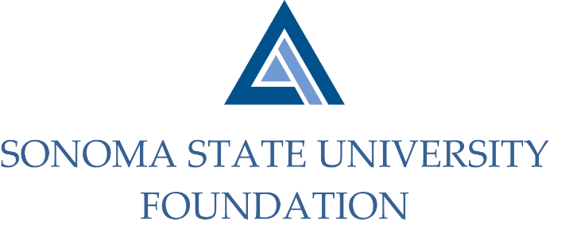

INVESTMENT COMMITTEE AGENDA

SSU Foundation Investment Committee Agenda
Thursday October 29th, 2020
Video/Teleconference Meeting
2:30 - 4:30 p.m.

Members: Ian Hannah (Co-Chair), Michael Sullivan (Co-Chair),
Mario A. Perez, Amanda Visser, Joyce Lopes, Tom Gillespie, Michael Troy, Brent Thomas, Terry Atkinson

Committee Staff: Kyle Bishop-Gabriel, Christina Shoptaugh

Guests: Todd Au, Tony Parmisano, Drew Aviles – Graystone Consulting

OPENING COMMENTS

APPROVAL OF THE MINUTES

8.4.20 Meeting Minutes

NACUBO-TIAA STUDY OF ENDOWMENTS 19/20 TALKING POINTS

GRAYSTONE – POOLED ENDOWMENT INVESTMENTS

Quarterly Update

GALBREATH ENDOWMENT INVESTMENTS QUARTERLY REPORT

INVESTMENT POOLS SHEET

OPEN ITEMS

