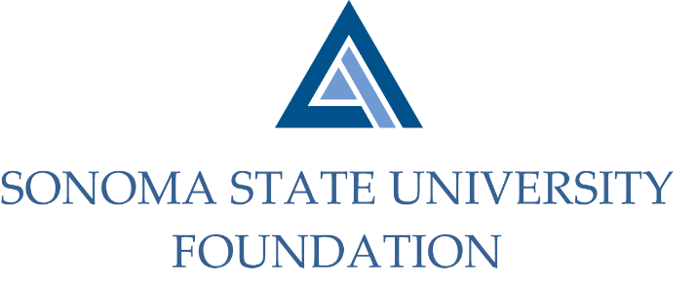

INVESTMENT COMMITTEE MINUTES

SSU Foundation Investment Committee
Wednesday January 29, 2020
Salazar Hall – Administration & Finance, Conference Room A
2:30 - 4:30 p.m.

Members Present: Ian Hannah (Co-Chair), Michael Sullivan (Co-Chair) (tele.), Amanda Visser, Tom Gillespie (tele.), Michael Troy, Brent Thomas

Committee Staff Present: Kyle Bishop-Gabriel

Guests Present: Todd Au, Tony Parmisano, Drew Aviles, Joanna Berg (tele.), Jeffrey Stein (tele.) – Graystone Consulting

Members Absent: Gordon McDougall, Joyce Lopes, Terry Atkinson

OPENING COMMENTS

Meeting opened at 2:31pm.

Hannah announced the new Vice President for University Advancement, Mario A. Perez, begins his new role February 10th. Perez will be coming from CSU Los Angeles bringing both CSU and private sector experience. His role will be Chairperson and President of SSUF and will serve on multiple committees.

APPROVAL OF THE MINUTES
(see 1.29.20 meeting packet)

Action: Committee unanimously approved 11.7.19 minutes.

NACUBO-TIAA STUDY OF ENDOWMENTS 18/19 COMPARATIVE DATA
(see 1.29.20 meeting packet)

Hannah reviewed the draft of the 18/19 Comparative Data sheet for the NACUBO-TIAA Study of Endowments results. The information provided is preliminary as the full report will not be released and available until March.
SSU’s total endowment reached $52.3M for 18/19 elevating it to the $50-$100M peer group. Committee members requested to see the $25-$50M group comparisons as well since the endowment just reached the new level. Staff noted request.

Hannah reviewed the rest of the preliminary information and once full results are received, staff will update the Comparative Data sheet to present to the Board.

GRAYSTONE – POOLED ENDOWMENT INVESTMENTS
(see 1.29.20 meeting packet)

Quarterly Report
Parmisano reviewed the capital market report for the 4th quarter with the committee.

Thereafter, Au proceeded with the Foundation’s endowment portfolio review. Performance for the quarter ending 12/31/19 was strong finishing with a 4.5% return amid solid performance from active managers.

Au noted to the committee that they are continuing to gradually move the portfolio to the new asset allocation targets noted in the updated investment policy.

Fund Recommendations
Joanna Berg proceeded to review with the committee two different private equity fund recommendations.
The Goldman Capabilities Vintage VII Fund and NB Select Opportunities Fund III were recommended to the committee for investment.

After the review and discussion the committee approved to invest in the funds.

Action: Committee unanimously approved investing $1M in the Goldman Capabilities Vintage VII Fund and $750k in the NB Opportunities Fund III.

GALBREATH ENDOWMENT INVESTMENTS QUARTERLY REPORT
(see 1.29.20 meeting packet)

Hannah did a brief review of the quarter earnings for the Galbreath Endowment. Returns for the 4th quarter were 4.1%

Hannah also informed committee that the investment managers from Merrill Lynch will be joining at a future scheduled investment committee to provide a detailed portfolio review.

QUASI ENDOWMENT FUND POLICY
(see 1.29.20 meeting packet)

Hannah reviewed the draft policy with committee, incorporating revisions discussed at the last meeting. He noted that other CSU Foundations were contacted to see if they had similar policies in place to utilize similar language. Only one applicable policy was located for quasi-endowments which gave ample language to use in drafting one for the SSU Foundation.

Action: Committee unanimously agreed to present the quasi-endowment policy to the Board for approval.

OPEN ITEMS

Hannah noted to committee that he and campus CFO, Joyce Lopes, will be meeting with the Associated Students (AS) President and AS VP for Finance regarding the Foundation’s current endowment investments. He noted that there has been some interest in understanding our portfolio holdings and fossil fuel investment exposure. He will keep committee posted on any potential outcomes of the meeting.

Meeting adjourned at 4:03pm.

Kyle Bishop-Gabriel – Redacted Signature
Ian Hannah – Redacted Signature
__________________________ ___________________________
Minutes Approved by: Minutes Prepared by:
Ian Hannah Kyle Bishop-Gabriel
Chief Operating Officer & Advancement/Foundation Analyst, SSU
Secretary, SSUF

