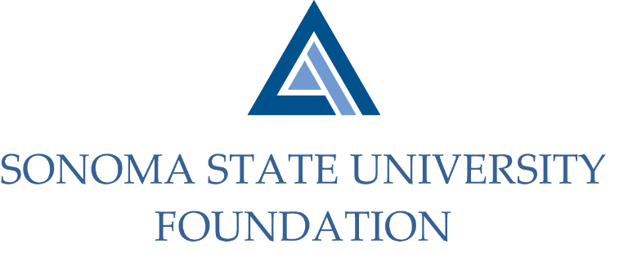

PHILANTHROPY COMMITTEE AGENDA

SSU Foundation Philanthropy Committee
Thursday August 27, 2020
Zoom/Teleconference
(for dial-in instructions please email kyle.bishop-gabriel@sonoma.edu)
3:00 – 4:30 p.m.

Members: Terry Atkinson (Chair), Tom Isaak, Robert U’Ren, Ian Hannah,
Mario Perez

Committee Staff: Kyle Bishop-Gabriel

Opening Comments

Review Charter

Review of Historical SSU Fundraising

Annual Giving Program
  - Annual Giving Calendar/Planning

Philanthropic Board Approach and Board Member Identification

Open Items

