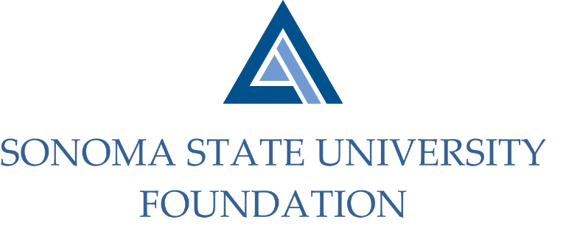

PHILANTHROPY & GOVERNANCE JOINT COMMITTEE AGENDA

SSU Foundation Philanthropy & Governance Committee
Thursday August 17, 2021
Zoom/Teleconference
(for dial-in instructions please email kyle.bishop-gabriel@sonoma.edu)
3:00 – 4:30 p.m.

Members: Terry Atkinson (Chair - Phil), David Felte (Chair – Gov), Tom Isaak (Phil & Gov), Robert U’Ren (Phil), Jeannette Anglin (Gov), Ian Hannah (Phil & Gov), Mario Perez (Phil & Gov)

Committee Staff: Kyle Bishop-Gabriel

Opening Comments

Approval of Minutes – 5.20.21

Joint Committee Goals

Philanthropic Productivity FY 20/21

Board Membership/Structure Changes

Foundation Philanthropic Priorities

Open Items

